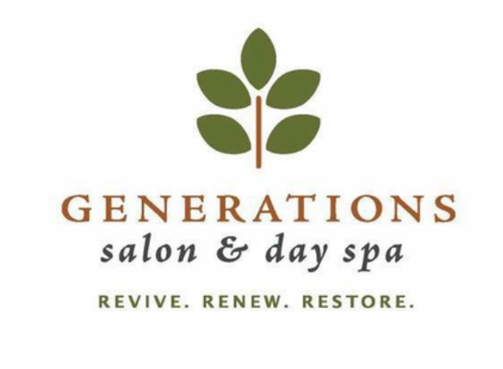
Photograph Release Form

I, hereby grant permission to Generations Salon INC, to use any portion of the photos or videos taken by Generations Staff member __________________________________________________________________ for the purpose of SELF USE and or SELF PROMOTION publications which can include but is not limited to, website, social media and or newsletters without any compensation or recognition given to me. Furthermore, I grant creative permission to alter the photographs, I do not grant permission to resale or use the photographs in any manner that would exploit or cause malicious representation toward me.
Permission granted on the date taken____________________________________________________________
Signed________________________________ Date ______________________________
Name Printed_______________________________________________

Generations Salon INC.
9650 Strickland Rd suite 153
Raleigh NC 27615
919-844-9422
gensalon.com

Owner signature ______________________________________ date____________________________

